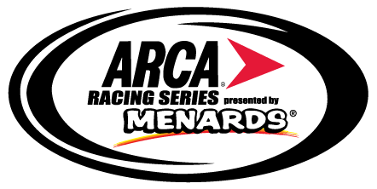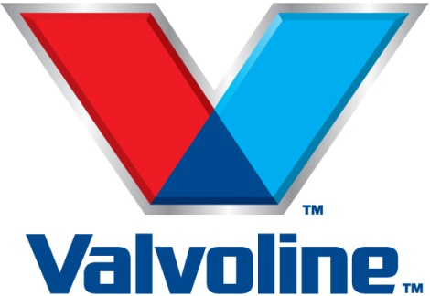

Valvoline extends its sponsorship as Official Motor Oil of the Automobile Racing Club of America
TALLADEGA, Ala. (May 6, 2017) -- Officials from the Automobile Racing Club of America (ARCA) announced today that Valvoline has extended its Official Motor Oil of the ARCA Racing Series partnership through 2018.
“The Valvoline Pro-V racing line has achieved outstanding success over the past two seasons across a variety of racing series,” said Jamal Muashsher, Valvoline’s vice president of marketing and customer experience. “We are excited to continue our partnership with the ARCA Racing Series, helping teams, drivers and crews reach victory lane.”
The announcement, made Saturday at Talladega Superspeedway, includes the news that Valvoline Pro-V Racing 0W30 motor oil will continue to be the exclusive oil for use in the ARCA Ilmor 396 engine package.
The ARCA Ilmor 396 engine, with Valvoline Motor Oil, debuted at the Daytona ARCA 200 in 2015. The Valvoline / ARCA Ilmor 396 combination is undefeated in the 43 events contested since, and has also won every General Tire pole award.
Ilmor engineers utilized the Pro-V Racing 0W30 motor oil extensively during the development, feasibility and durability testing of the ARCA Ilmor 396, including extensive testing on the engine dyno, SpinTron, chassis dyno and on-track.
The extensive testing convinced both Ilmor and ARCA that the Pro-V Racing 0W30 was the right product to help both ARCA and Ilmor achieve the performance standards established.
“Valvoline is an iconic motorsports brand long synonymous with winning and on-track performance,” said ARCA President Ron Drager. “Valvoline Pro-V Racing was selected as the exclusive oil for the ARCA Ilmor 396 engine package based on its high quality in testing. Now in its third season and after thousands of miles of on-track competition at 200 mph superspeedways, dirt and paved short tracks and road courses, Valvoline Pro-V Racing has been in the engine of every winning race car for 43 consecutive races.”
ABOUT VALVOLINE:
Valvoline Inc. (NYSE:VVV) is a leading worldwide producer and distributor of premium branded automotive, commercial and industrial lubricants, and automotive chemicals. Valvoline ranks as the #2 quick-lube chain by number of stores and #3 passenger car motor oil brand in the DIY market by volume in the United States. The brand operates and franchises more than 1,070 Valvoline Instant Oil ChangeSM centers in the United States. It also markets Valvoline™ lubricants and automotive chemicals; MaxLife™ lubricants created for higher-mileage engines, SynPower™ synthetic motor oil; and Zerex™ antifreeze. Visit Valvoline.com to learn more.
ABOUT ARCA
The Automobile Racing Club of America (ARCA) is among the leading and most versatile auto racing sanctioning bodies in the country. Founded in 1953 by John and Mildred Marcum, the organization administers more than 100 events each year in multiple racing series, including the ARCA Racing Series presented by Menards, the ARCA/CRA Super Series and the ARCA Midwest Tour, plus weekly racing at Toledo and Flat Rock Speedways.
ABOUT ILMOR
Ilmor Engineering, Inc. is a globally recognized provider of high-performance engines. We deliver innovative solutions, precision design and manufacturing, and the highest levels of customer support for each and every one of our products, and we continually seek new and better ways to maximize power, durability and efficiency in everything we do.
Originally formed from Mario Illien and Paul Morgan's partnership with Roger Penske, Ilmor was founded to build turbocharged engines for the American-based IndyCar series, and served as the power behind many winning drivers and teams. Today, we employ more than 90 engineering, assembly and support personnel, and have expanded into several other open wheel racing circuits, including NASCAR, ARCA, Kart, Midget and Desert Truck.
Whether on land or at sea, Ilmor continues to innovate better and more efficient solutions, and to exceed expectations for reliability, precision and overall performance. Our customers count on our engines to look like no other, sound like no other and out-perform ALL the others.
Contact:
Don Radebaugh
ARCA Communications Manager
dradebaugh@arcaracing.com

